**Section 4(Pushing source code to remote repository using Eclipse GIT Plugin)**

Created private repository “SampleProj” and pushed java project onto it.

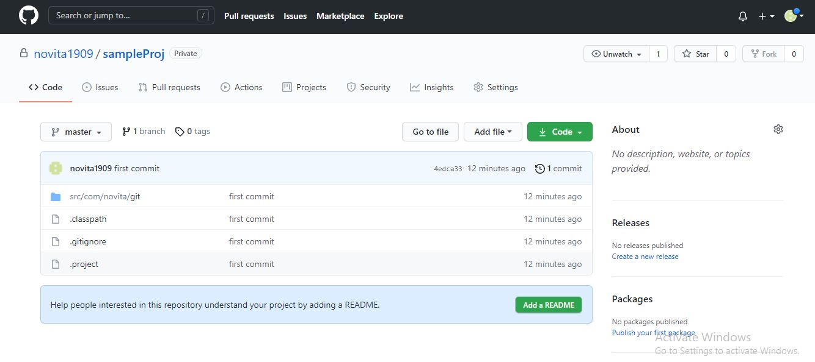

Collaborated with Piyush so that he can modify the files in my repository

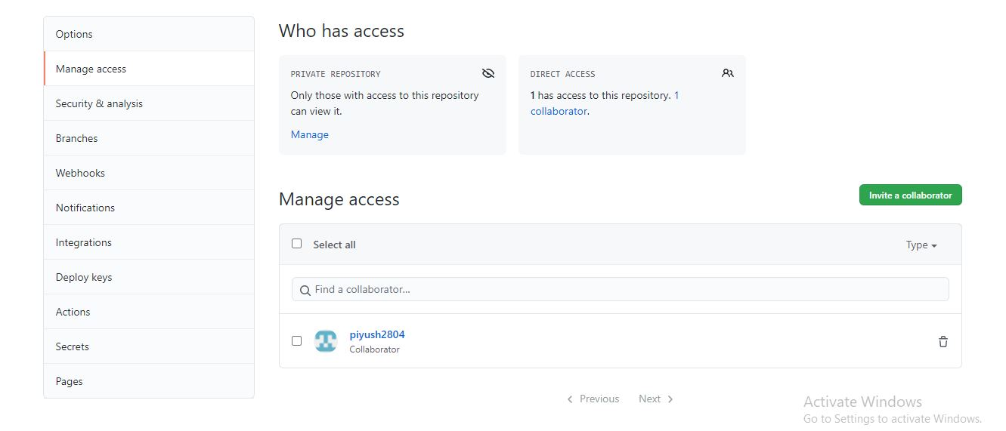

Changes made by Piyush in repository “SampleProj”

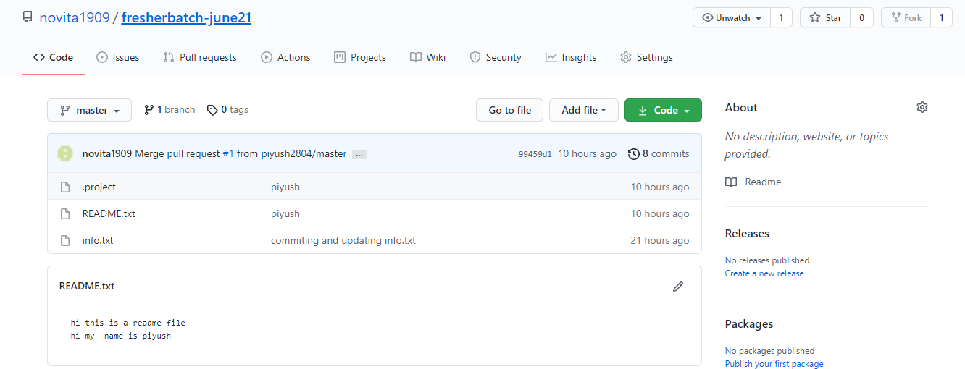

Checkout all files from Dinesh’s repository (java_project )and imported in my Eclipse and and modified the files(Added Hello.java class)

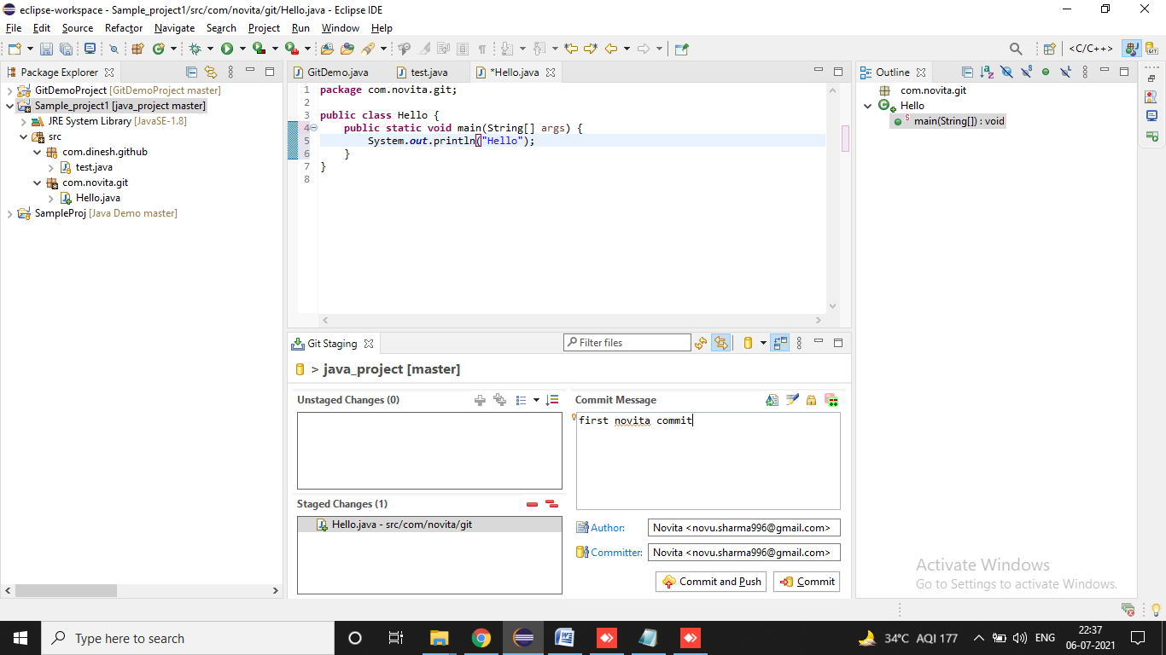

Merging back to Dinesh’s repository java_project (Creating new Branch NovitaBranch )

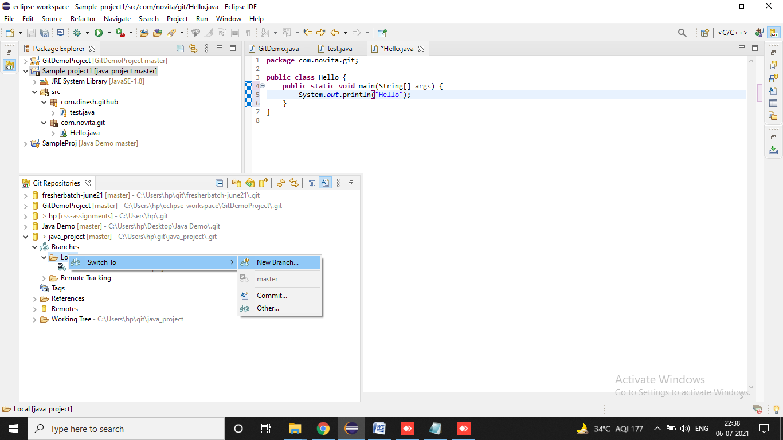

Committing to new created Branch

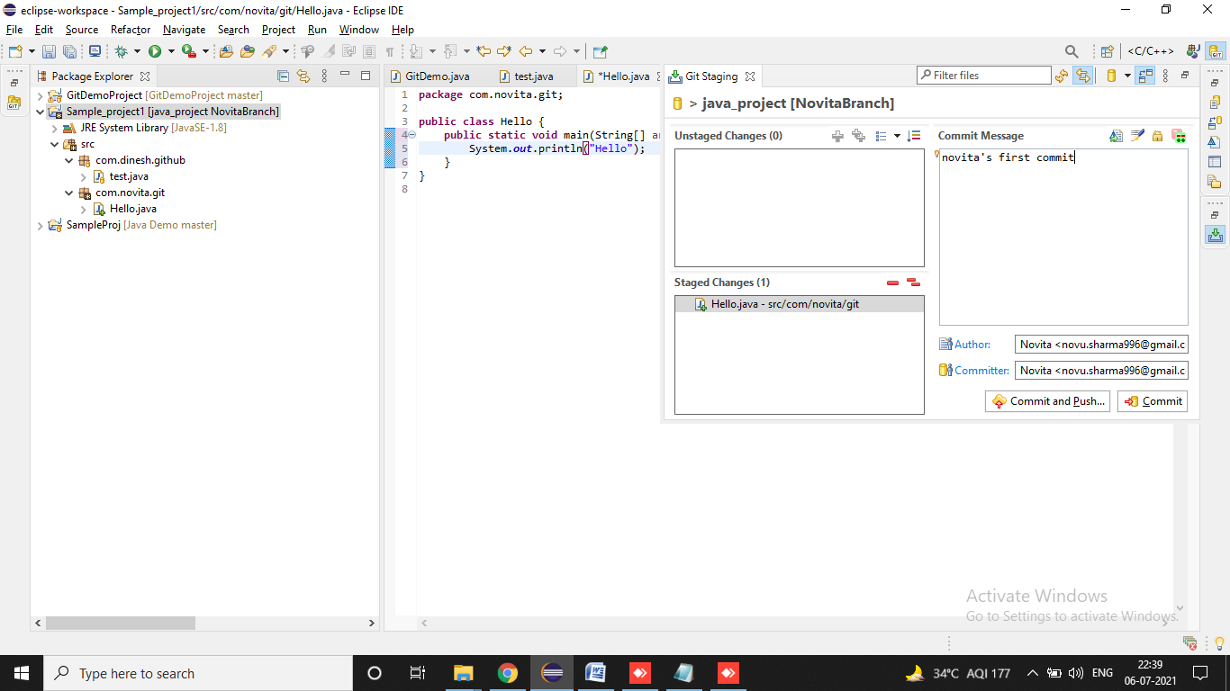

Push

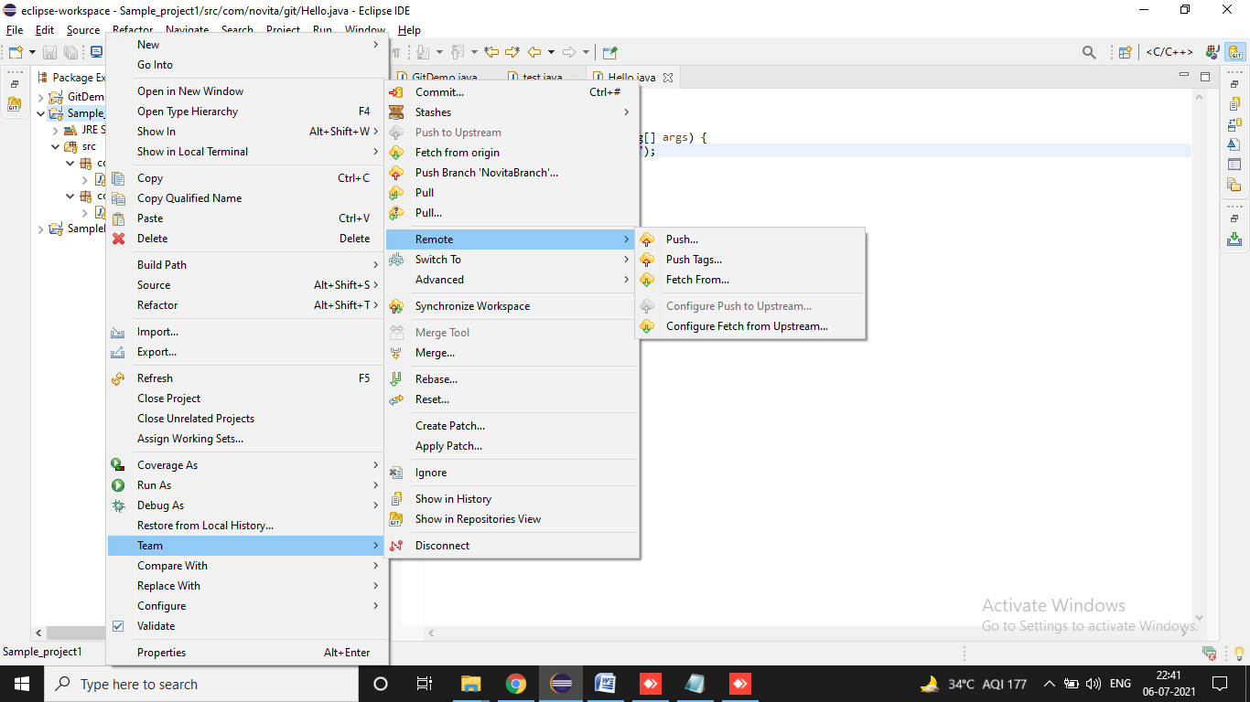

Creating a pull request

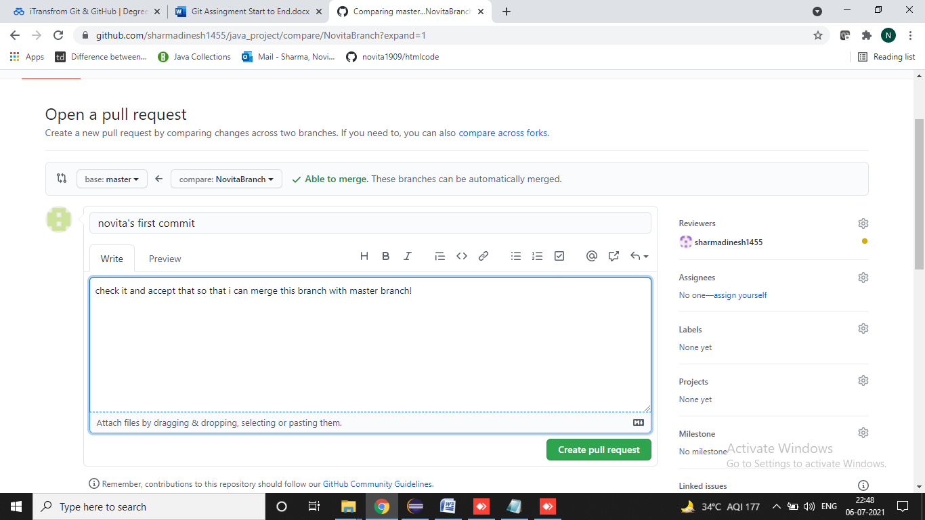

After approving pull request

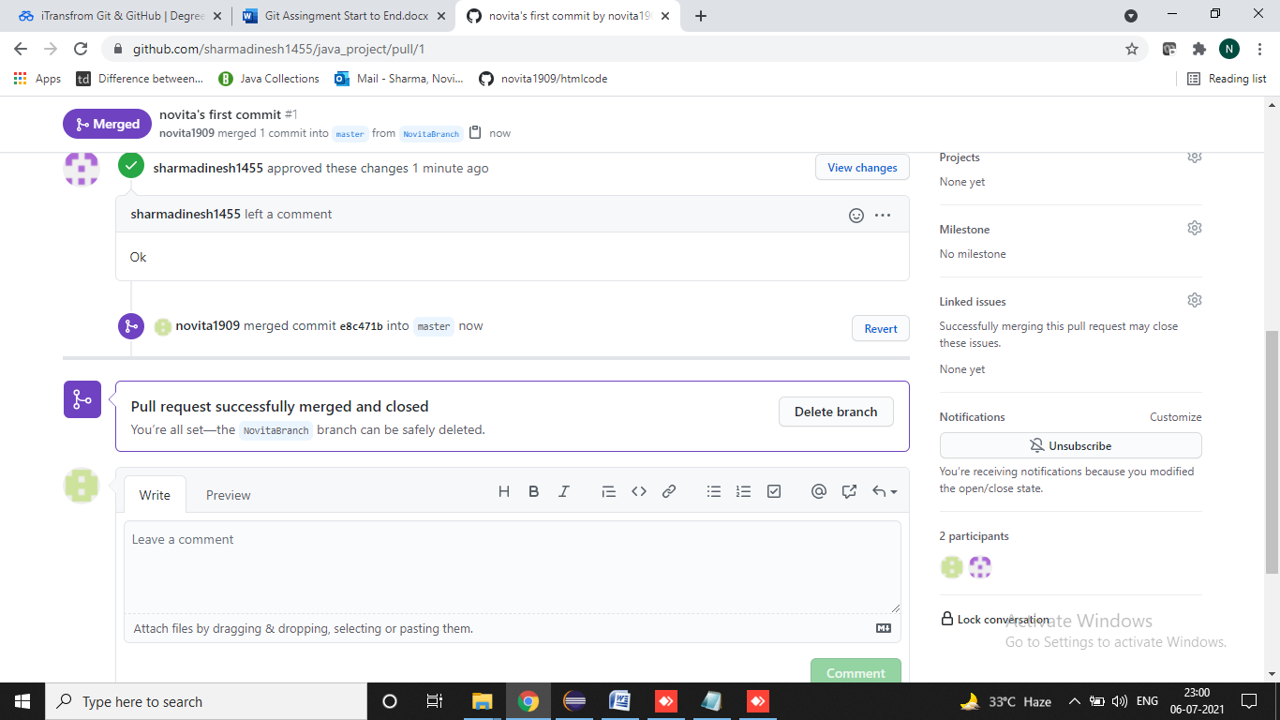

Changes made in Dinesh’s java_project repo

